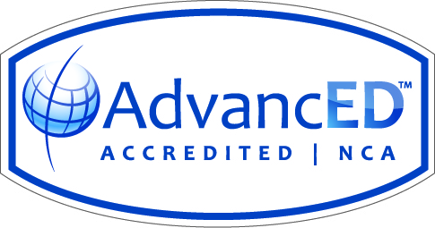
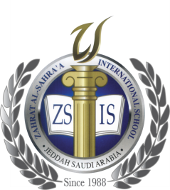
Zahrat Al-Sahra’a International School
Academic Year 2018-2019

Subject: Science Date : 4th November 2018

Lessons included: Test # 1/Term 1

Grades | Test 1
Grade 4 | Unit 3: Plants and Animals  Lesson 2: How Do Plants Reproduce  Lesson 4: How Do Animals Reproduce  Lesson 5: How are Living Things Adapted to their  Environment  Lesson Reviews + Revision Sheet are included
Grade 5 | Unit 3: Cells to Body systems  Lesson 3: How Do cells Work together? (P.128 to 134)  Lesson 4: How Do Our Bodies Move, Breathe and  Circulate Blood?  Lesson 5: How Do Our Bodies Digest Food, Remove  wastes and Send Messages? (P.154 to 159)  Lesson Reviews + Revision Sheet are included
Grade 6 | Unit 1: Earth’s Water:  Lesson 3: Surface water and Ground Water  Unit 3: Earth’s Atmosphere:  Lesson 1: The Atmosphere  Lesson Reviews + Revision Sheet are included

